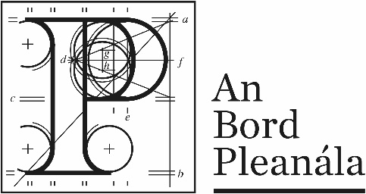
Documents received at Oral Hearing for
ABP-314232-22

Case Description | DART+ West Railway Order - Dublin City to Maynooth and M3 Parkway County Dublin, County Meath, County Kildare
Date | 13th October, 2023
Location | The Gresham Hotel, 23 O’Connell Street Upper, North City, Dublin, D01 C3W7

Documents received at Oral Hearing
No. | Submitted by | Presenter | Topic
 | Applicant |  | Level Drawings
 | Applicant |  | Surface Water
 | Applicant |  | Depot Arch Drawings
 | Applicant |  | Building heights - erata
 | Kevin Reid – Ashtown Stables |  | Closing Statement
 | Navan Road Community Council |  | Closing Statement
 | Fingal County Council |  | Closing Statement

